NATIONAL UNIVERSITY OF TECHNOLOGY

DEPARTMENT OF COMPUTER SCIENCE


BATCH: ARTIFICIAL INTELLIGENCE 2024
ICAT PROJECT
Date: FEBRUARY 08, 2025
Project title:Language Learning Application

PROJECT PARTICIPANTS: SUPERVISED BY:
- SARDAR ZAKIULLAH MA’AM FARIA
- HAIDER ALI
- HARIS ALI
- ABDUL QADEER
- TAHIR HUSSAIN

Introduction
Project Title: Language Learning Application
Objective: The Language Translator application is designed to facilitate translation between different languages. It allows users to input text in one language, select target languages, and get translations with additional features such as text-to-speech and copy-to-clipboard.
Technologies Used:
- HTML
- CSS
- JavaScript
- MyMemory API for translation
- Web Speech API for text-to-speech
Mediums Used
- Code Pen
- Tiiny.host
- Web into app

Project Overview
The Language Translator application consists of a web interface that allows users to input text, select source and target languages, and receive translations. The application features a clean and user-friendly design with support for multiple languages.

3. HTML Structure
The HTML file provides the structure for the user interface. Here is a breakdown:
<!DOCTYPE html>
<html lang="en" dir="ltr">
<head>
<meta charset="utf-8">
<title>Language Translator </title>
<meta name="viewport" content="width=device-width, initial-scale=1.0">
<link rel="stylesheet" href="style.css">
<!-- Font Awesome CDN Link for Icons -->
<link rel="stylesheet" href="https://cdnjs.cloudflare.com/ajax/libs/font-awesome/5.15.3/css/all.min.css"/>
</head>
<body>
<div class="container">
<div class="wrapper">
<div class="text-input">
<textarea spellcheck="false" class="from-text" id="from-text" placeholder="Enter text"></textarea>
<textarea spellcheck="false" readonly disabled class="to-text" id="to-text" placeholder="Translation"></textarea>
</div>
<ul class="controls">
<li class="row from">
<div class="icons">
<i id="from" class="fas fa-volume-up" aria-label="Read text aloud"></i>
<i id="from" class="fas fa-copy" aria-label="Copy text"></i>
</div>
<select id="from-lang" aria-label="Select language to translate from"></select>
</li>
<li class="exchange" aria-label="Swap languages"><i class="fas fa-exchange-alt"></i></li>
<li class="row to">
<select id="to-lang" aria-label="Select language to translate to"></select>
<div class="icons">
<i id="to" class="fas fa-volume-up" aria-label="Read translation aloud"></i>
<i id="to" class="fas fa-copy" aria-label="Copy translation"></i>
</div>
</li>
</ul>
<button aria-label="Translate text">Translate Text</button>
</div>
<div class="credits">
<p>Designed and Developed By:</p>
<ul>
<li> Sardar Zakiullah - F24607027 </li>
<li> Haris Ali - F24607039</li>
<li> Haider Ali - 24607032</li>
<li> Tahir Hussain - F24607045</li>
<li> Abdul Qadeer- F24607044</li>
</ul>
</div>
</div>

<script src="js/countries.js"></script>
<script src="js/script.js"></script>
</body>
</html>

Explanation:
- <head> Section: Includes meta tags for character set and viewport settings, links to the stylesheet (style.css), and Font Awesome for icons.
- <body> Section: Contains the main content of the application including text areas for input and output, language selection dropdowns, control buttons, and a translate button.

CSS Styling
The CSS file styles the user interface, providing a responsive and aesthetically pleasing design:
/* Import Google Font - Poppins */
@import url('https://fonts.googleapis.com/css2?family=Poppins:wght@400;500;600;700&display=swap');

*{
margin: 0;
padding: 0;
box-sizing: border-box;
font-family: 'Poppins', sans-serif;
}
body{
display: flex;
align-items: center;
justify-content: center;
padding: 0 10px;
min-height: 100vh;
background: #5372F0;
}
.container{
max-width: 690px;
width: 100%;
padding: 30px;
background: #fff;
border-radius: 7px;
box-shadow: 0 10px 20px rgba(0,0,0,0.01);
}
.wrapper{
border-radius: 5px;
border: 1px solid #ccc;
}
.wrapper .text-input{
display: flex;
border-bottom: 1px solid #ccc;
}
.text-input .to-text{
border-radius: 0px;
border-left: 1px solid #ccc;
}
.text-input textarea{
height: 250px;
width: 100%;
border: none;
outline: none;
resize: none;
background: none;
font-size: 18px;
padding: 10px 15px;
border-radius: 5px;
}
.text-input textarea::placeholder{
color: #b7b6b6;
}
.controls, li, .icons, .icons i{
display: flex;
align-items: center;
justify-content: space-between;
}
.controls{
list-style: none;
padding: 12px 15px;
}
.controls .row .icons{
width: 38%;
}
.controls .row .icons i{
width: 50px;
color: #adadad;
font-size: 14px;
cursor: pointer;
transition: transform 0.2s ease;
justify-content: center;
}
.controls .row.from .icons{
padding-right: 15px;
border-right: 1px solid #ccc;
}
.controls .row.to .icons{
padding-left: 15px;
border-left: 1px solid #ccc;
}
.controls .row select{
color: #333;
border: none;
outline: none;
font-size: 18px;
background: none;
padding-left: 5px;
}
.text-input textarea::-webkit-scrollbar{
width: 4px;
}
.controls .row select::-webkit-scrollbar{
width: 8px;
}
.text-input textarea::-webkit-scrollbar-track,
.controls .row select::-webkit-scrollbar-track{
background: #fff;
}
.text-input textarea::-webkit-scrollbar-thumb{
background: #ddd;
border-radius: 8px;
}
.controls .row select::-webkit-scrollbar-thumb{
background: #999;
border-radius: 8px;
border-right: 2px solid #ffffff;
}
.controls .exchange{
color: #adadad;
cursor: pointer;
font-size: 16px;
transition: transform 0.2s ease;
}
.controls i:active{
transform: scale(0.9);
}
.container button{
width: 100%;
padding: 14px;
outline: none;
border: none;
color: #fff;
cursor: pointer;
margin-top: 20px;
font-size: 17px;
border-radius: 5px;
background: #5372F0;
}

@media (max-width: 660px){
.container{
padding: 20px;
}
.wrapper .text-input{
flex-direction: column;
}
.text-input .to-text{
border-left: 0px;
border-top: 1px solid #ccc;
}
.text-input textarea{
height: 200px;
}
.controls .row .icons{
display: none;
}
.container button{
padding: 13px;
font-size: 16px;
}
.controls .row select{
font-size: 16px;
}
.controls .exchange{
font-size: 14px;
}
}

Explanation:
- General Styling: Defines a clean, modern look using the Poppins font and consistent padding and margins.
- Container and Wrapper: Provides a centered layout with a white background, rounded corners, and shadow effects.
- Text Areas: Styled to be full-width with custom scrollbar styles.
- Controls and Icons: Flexbox layout for the controls and interactive icons, including transition effects for clicks.
- Responsive Design: Adjusts the layout for smaller screens, including font sizes and element visibility.

JavaScript Functionality
The JavaScript file adds interactive functionality to the application
const countries = { /* Country Codes and Names */ }

const fromText = document.querySelector(".from-text"),
toText = document.querySelector(".to-text"),
exchageIcon = document.querySelector(".exchange"),
selectTag = document.querySelectorAll("select"),
icons = document.querySelectorAll(".row i");
translateBtn = document.querySelector("button"),

selectTag.forEach((tag, id) => {
for (let country_code in countries) {
let selected = id == 0 ? country_code == "en-GB" ? "selected" : "" : country_code == "hi-IN" ? "selected" : "";
let option = `<option ${selected} value="${country_code}">${countries[country_code]}</option>`;
tag.insertAdjacentHTML("beforeend", option);
}
});

exchageIcon.addEventListener("click", () => {
let tempText = fromText.value,
tempLang = selectTag[0].value;
fromText.value = toText.value;
toText.value = tempText;
selectTag[0].value = selectTag[1].value;
selectTag[1].value = tempLang;
});

fromText.addEventListener("keyup", () => {
if(!fromText.value) {
toText.value = "";
}
});

translateBtn.addEventListener("click", () => {
let text = fromText.value.trim(),
translateFrom = selectTag[0].value,
translateTo = selectTag[1].value;
if(!text) return;
toText.setAttribute("placeholder", "Translating...");
let apiUrl = `https://api.mymemory.translated.net/get?q=${text}&langpair=${translateFrom}|${translateTo}`;
fetch(apiUrl).then(res => res.json()).then(data => {
toText.value = data.responseData.translatedText;
data.matches.forEach(data => {
if(data.id === 0) {
toText.value = data.translation;
}
});
toText.setAttribute("placeholder", "Translation");
});
});

icons.forEach(icon => {
icon.addEventListener("click", ({target}) => {
if(!fromText.value || !toText.value) return;
if(target.classList.contains("fa-copy")) {
if(target.id == "from") {
navigator.clipboard.writeText(fromText.value);
} else {
navigator.clipboard.writeText(toText.value);
}
} else {
let utterance;
if(target.id == "from") {
utterance = new SpeechSynthesisUtterance(fromText.value);
utterance.lang = selectTag[0].value;
} else {
utterance = new SpeechSynthesisUtterance(toText.value);
utterance.lang = selectTag[1].value;
}
speechSynthesis.speak(utterance);
}
});
});
Explanation:
- Country Data: Defines language codes and names used for language selection.
- Element Selection: Queries and stores references to HTML elements for further manipulation.
- Language Options: Populates language dropdowns with options and sets default selected values.
- Exchange Functionality: Swaps the source and target text and languages when the exchange icon is clicked.
- Text-to-Speech and Copy: Implements text-to-speech and copy functionality for the text areas.
- Translation Logic: Fetches translation data from the MyMemory API and updates the target text area.
Final Layout Screenshot
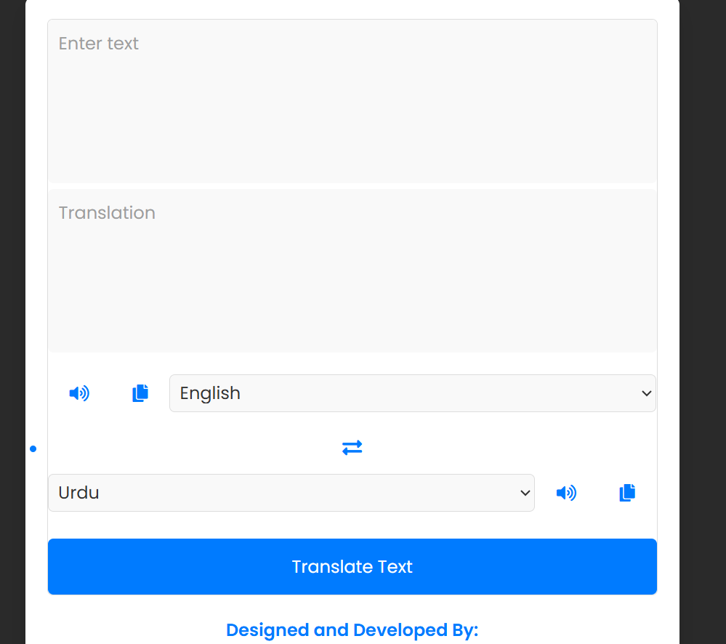
Future Expected Updates
• Enhanced API Integration: Consider integrating with more advanced translation APIs for better accuracy.
• Offline Mode: Implement offline capabilities to provide translations without internet access.
• User Profiles: Allow users to save their translation history and preferences.
Refrences
https://languagelearningapp.tiiny.site/
UN SDGs BEING FOLLOWED:
-fourth sdg: QUALITY OF EDUCATION
-Tenth sdg: REDUCED INEQUALITIES
-Sixteenth sdg:PEACE AND JUSTICE
Conclusion
The Language Translator application offers a functional and user-friendly interface for translating text between different languages. With features such as text-to-speech and clipboard copying, it is well-suited for educational and practical use cases.

